 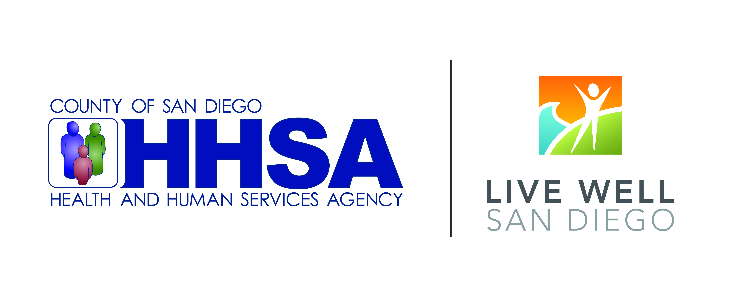

***Live Well San Diego***

**Resident Leadership Academy (RLA)**

Overview:

RLA is a ten-session training for neighborhood leaders that prepares participants to identify barriers to health, safety and well-being in their communities and then work collaboratively on community improvement projects to remove those barriers.

|  |  |
| --- | --- |
| **SESSION** | **DESCRIPTION** |
| 1. Orientation | Introduces the *Live Well San Diego* vision, the description, history, and benefits of the Resident Leadership Academy (RLA) curriculum. Summarizes the individual chapters of the curriculum. Chapter topics provide a holistic view of public health and a methodology that facilitates the empowerment of residents to affect change in their own neighborhoods. |
| 1. Community Building Principles | Defines social capital and the benefits of a diverse community environment. Identifies how community building occurs and sets the stage for effective community action, outlining the steps for residents to become effective community leaders. |
| 1. Social Determinants of Health | Defines the social determinants of health inequities and describes how socioeconomic factors and neighborhood characteristics shape behaviors. Identifies strategies to address those factors and move towards health equity. Discusses the role of neighborhood, home and work environments in determining health and the quality of life. |
| 1. Safe Walkable Communities | Describes the core principles of walkability, methodologies to assess neighborhood conditions for pedestrians and cyclists, and the core concepts of Crime Prevention Through Environmental Design (CPTED) and how CPTED can lead to enhanced civic engagement. Examples of strategies to increase walkability include: Increased physical activity opportunities, safe routes to schools programs, and the addition of crosswalks. |
| 1. Healthy Food Systems | Summarizes the components of the food system at global, regional and local scales. Describes factors that lead to obesity and diet-related chronic disease. Identifies strategies to increase access to healthy foods. Examples of strategies discussed include: corner store makeovers, installation of community gardens, and addition of farmers markets. |

***Live Well San Diego***

**Resident Leadership Academy (RLA)**

|  |  |
| --- | --- |
| **SESSION** | **DESCRIPTION** |
| 1. Land Use and Community Planning | Provides an overview of the complexities of land use and community planning and how community design can impact healthy behaviors. Identifies key planning documents and agencies. Outlines strategies for influencing land use policy and improving the built environment. |
| 1. Leadership – Advocacy and Policy Development | Defines key terms within advocacy and policy development. Identifies the steps of effective community action including needs/issue assessment and strategic planning. Outlines different mechanisms for creating community change, such as coalition building, policy change and direct interaction with decision makers. |
| 1. Community Improvement Project – Needs & Opportunity Assessment | Describes how to utilize needs assessment tools and strategies to collect data and define issues within the community, with the ultimate goal of implementing community change campaigns in the form of Community Improvement Projects (CIPs). Examples of CIPs include: health education classes, park lighting additions, and intersection murals. |
| 1. Community Improvement Project – Planning & Implementation Session | Outlines how to prioritize community issues for action and select a focus for Community Improvement Projects. Identifies actions to mobilize community stakeholders and decision makers to support the projects. Outlines the steps of Action Plan development. |
| 1. Community Improvement Project – Evaluation & Celebration Session | Each RLA culminates in one or more Community Improvement Project(s) developed and implemented by resident leaders. This final chapter reviews evaluation of the impact of the CIPs and focuses on the value of celebration and acknowledgement of achievements. |

  
For more information, contact:

Insert facilitator or coordinator contact information.