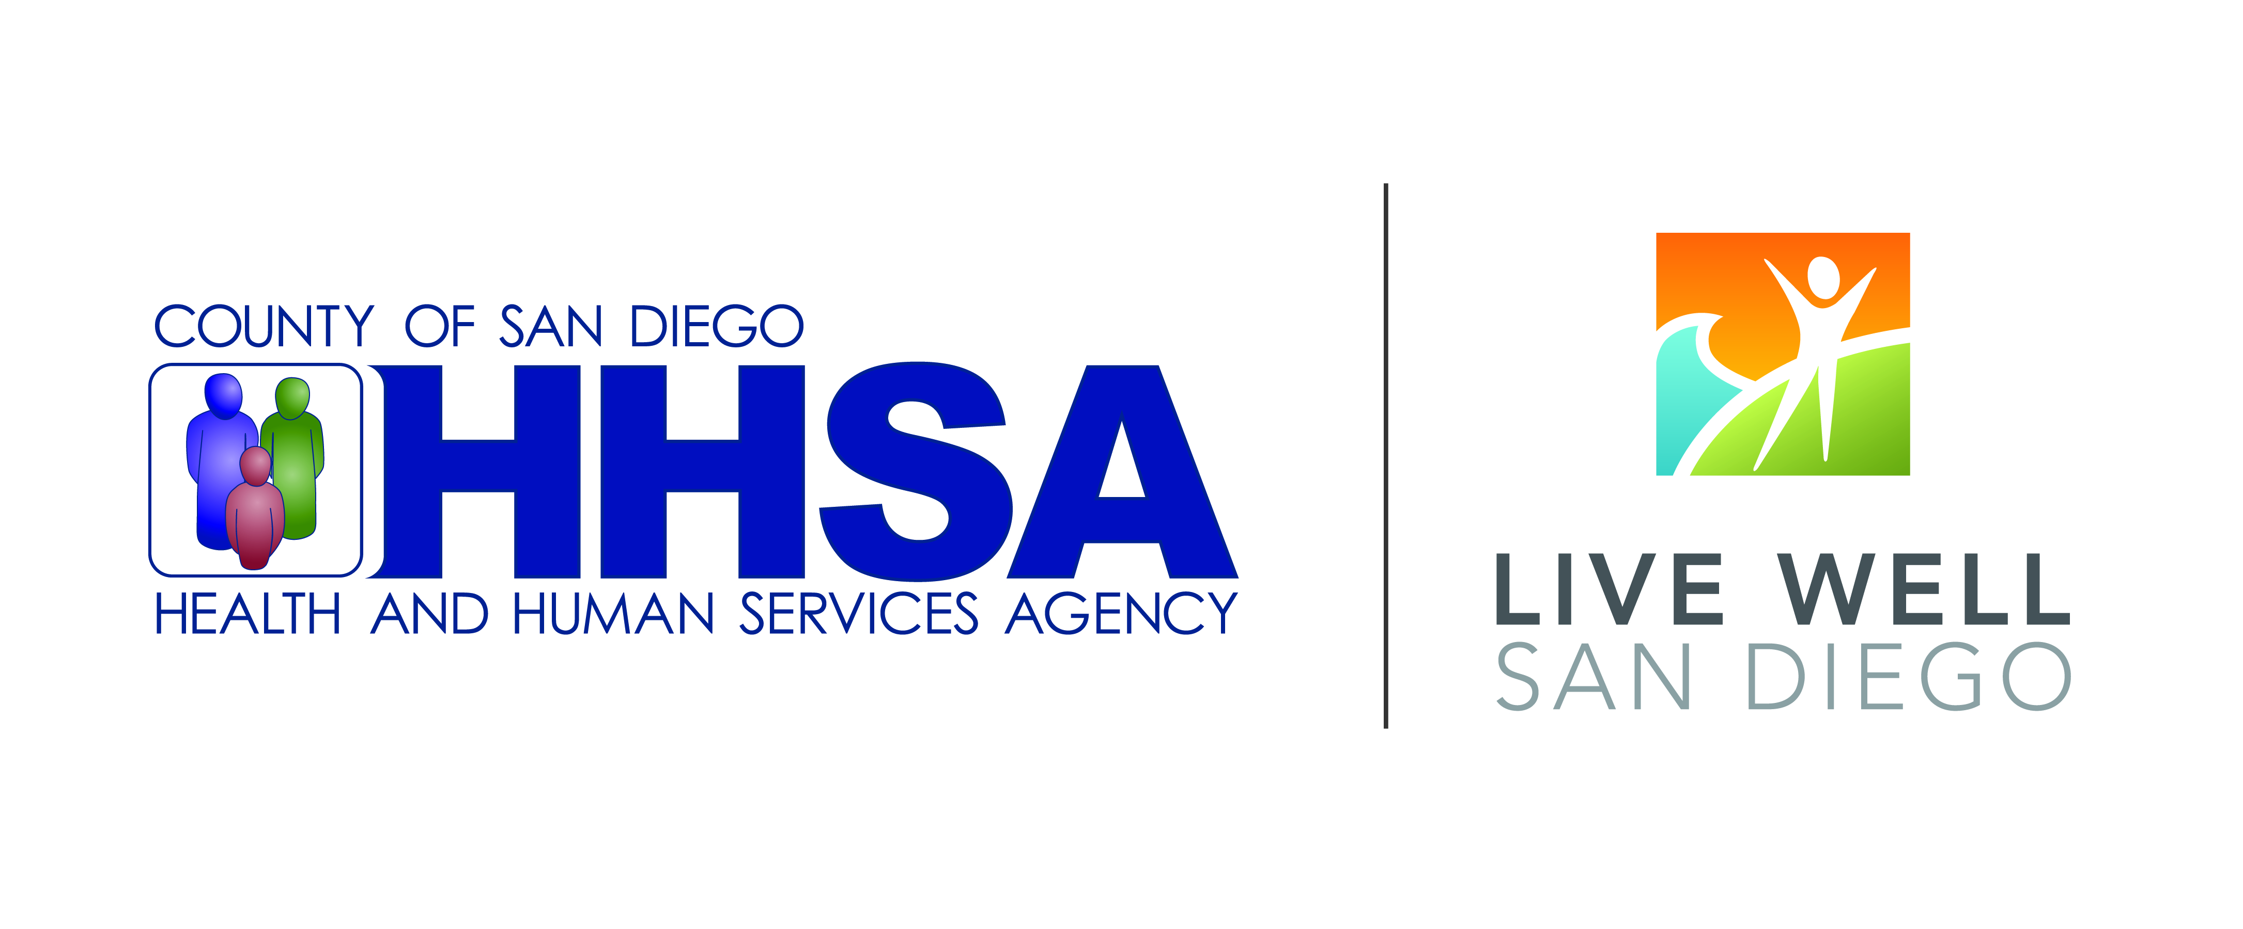

**Resident Leadership Academy**

**Knowledge Post Survey**

***Background: You are being asked to complete this assessment to the best of your ability on the first and last days of the RLA. We are not evaluating your learning as an individual; we are only trying to assess how much the group as a whole has learned. We will not be requesting your name for this test, but please provide the last four digits of your social security number, to provide us a means of analyzing the pre-test scores vs post test scores using an unique ID number.***

***Last four digits of SSN:_______________________ Score _________***

***Please Circle or mark one correct answer:***

1. **A community can make positive changes in the health of its residents by changing the environment.**

1. True
2. False

2. **Obesity is related to individual choices AND community factors such as the number of fast food restaurants or availability of safe areas for walking or exercise.**

1. True
2. False

3. **Getting to know your neighbors is NOT an important part of making changes in your community.**

1. True
2. False

4. **One way of creating change in a community is to get a lot of people in the community involved.**

1. True
2. False

5. **The most important aspect of being a leader is being able to speak in public.**

1. True
2. False

6. **Listening is an important part of community building.**

1. True
2. False

7. **Conventional food systems are concerned with producing a lot of inexpensive food.**

1. True
2. False

8. **Of the items below, which of the following is NOT true regarding the *Live Well San Diego* Initiative**

**as launched by the County of San Diego Board of Supervisors:**

(Select the response which is NOT true)

a. Includes 3 components—Building Better Health, Living Safely and Thriving

b. Involves everyone working together including input from the entire community and every sector

c. Is a short-term initiative because this kind of change effort can be accomplished quickly

**What are two ways you can improve the quality of food you serve your family?**

1._________________________________________________________________________________________________________________________________________________________________________

2._________________________________________________________________________________________________________________________________________________________________________

**Please list two things that you’ve learned about your community during the assessments that you would like to change.**

1._________________________________________________________________________________________________________________________________________________________________________

2._________________________________________________________________________________________________________________________________________________________________________

**How does your community’s layout or environment affect your health?**

_____________________________________________________________________________________

__________________________________________________________________________________________________________________________________________________________________________

**Please describe how you will know if your community improvement project is successful.**

_____________________________________________________________________________________

__________________________________________________________________________________________________________________________________________________________________________