Live Well San Diego is Now MOBILE!

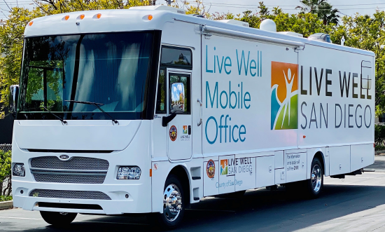

Live Well on Wheels (LIVE WOW) is fully equiped to offer a variety of resources to our communities. The vehicle is available by request to schools and community partners.

Schools may submit a request to have the vehicle and county staff visit their event or site and provide a variety of services such as:

* **Application enrollment assistance for public benefits such as CalFresh and Medi-Cal**
* **Immunizations**
* **Health screenings**
* **Providing information about other community resources**
* **And more!**

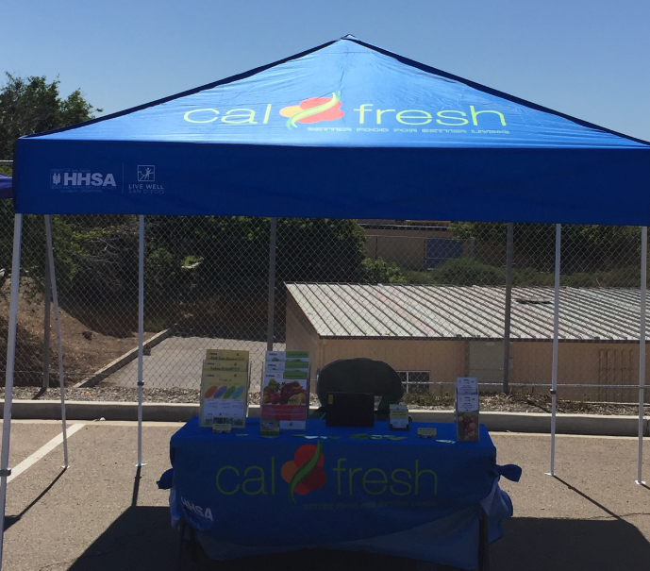 

**For more information and for future vehicle request, visit** [Livewellsd.org/mobile](https://www.livewellsd.org/content/livewell/home/community/live-well-on-wheels.html)